CHANGE CONTROL PROCESS
Doc #: RS-COP-03



Ramschip, Inc.
Quality management Div.
5F 506.43, Changeop-ro, Sujeong-gu, Seongnam-si, Gyeonggi-do, South Korea (13449)
Tel. +82.31.622.7790

RS-COP-03 Revision history

Rev. no | Rev. date | Simple description of changed contents | Author | Post
1.0 | 2022.09.22 | Newly established. | Mark.Kim | QM
1.1 | 2025.06.11 | Document form update | Mark. Kim | QM

1. Purpose and scope
The purpose of this Change Management Process Standard is to define a systematic and controlled approach for managing changes in semiconductor IP design and development. In the highly complex and quality-sensitive domain of IP design, even minor changes to specifications, RTL code, verification environments, or design methodologies can significantly affect functionality, performance, compatibility, and deliverable schedules. Therefore, this standard ensures that all proposed changes are carefully reviewed, evaluated for impact, approved by designated stakeholders, and fully documented before implementation.
By establishing a clear process for initiating, assessing, and tracking design changes, this standard helps maintain design consistency, traceability, and compliance with internal quality requirements and customer expectations. It also supports effective communication across cross-functional teams—including design, verification, validation, and project management—thus minimizing the risk of errors or misalignment during the product lifecycle. Ultimately, this process contributes to delivering high-quality semiconductor IPs that meet stringent market and customer requirements.
2. Apply scope
This Change Management Process applies to all semiconductor IP design and development activities within the organization, including but not limited to digital and analog IPs, PHYs, controllers, and subsystems. It covers changes to design specifications, RTL or schematics, verification environments, simulation or testbench configurations, design methodologies, documentation, and related tools or workflows.
The process is applicable throughout the entire IP development lifecycle—from initial architecture definition and design implementation to verification, validation, tape-out preparation, and post-silicon updates. It is mandatory for all teams involved in IP development, including design, verification, physical implementation, project management, and quality assurance.
3. Definition of terms
3.1 Change request
A formal proposal to modify a design specification, RTL code, verification environment, or related documentation. A CR must be submitted, reviewed, and approved before implementation.
3.3 Design change
Any modification to the existing IP design, including RTL updates, schematic changes, constraint modifications, or changes in IP configuration option.
3.4 Verification Environment
The testbench, simulation tools, test scenarios, and models used to verify the correctness of an IP design.
3.5 Impact Analysis
The process of assessing the potential effects of a proposed change on functionality, performance, schedule, resources, and deliverables.
3.6 Change Control Board (CCB)
A designated group of stakeholders responsible for reviewing and approving/rejecting change requests. Typically includes representatives from design, verification, project management, and quality teams.
3.7 Baseline
A formally reviewed and agreed-upon version of a design or document that serves as a starting point for further development or change control.
3.8 Traceability
The ability to track the history, implementation, and approval of changes across all affected components and documents.
3.9 Deviation
A temporary or exceptional departure from an approved baseline or standard, usually requiring separate approval.
4. Responsibility and authority
To ensure effective and traceable change management within semiconductor IP design, the following roles and responsibilities are defined:
4.1 IP Design engineer
1) Responsible for identifying necessary changes related to design implementation.
2) Prepares and submits Change Requests (CRs) with technical justification and impact analysis.
3) Implements approved changes and ensures updated files are committed to version control.
4.2 Verification engineer
1) Reviews CRs from the verification perspective to assess potential impacts on test environments and coverage.
2) Updates testbenches or test plans accordingly if the change is approved.
3) Verifies the correctness and completeness of the change before sign-off.
4.3 Project manager (PM)
1) Ensures that all proposed changes are aligned with project schedules and resource plans.
2) Facilitates Change Control Board (CCB) meetings and tracks the status of CRs.
3) Has the authority to escalate unresolved issues to management.
4.4 Change Control Board (CCB)
1) A cross-functional group consisting of design, verification, QA, and PM representatives.
2) Reviews submitted CRs, evaluates risks, and makes approval/rejection decisions.
3) Ensures all approved changes are properly documented and communicated to stakeholders.
4.5 Quality Assurance (QA)
1) Audits change records and verifies compliance with the change management process.
2) Ensures traceability of changes and maintains process integrity.
3) May withhold final IP release approval if critical changes are not properly managed.
4.6 Configuration Manager (If applicable)
1) Maintains version control systems and ensures that only approved versions are released.
2) Supports rollback or recovery processes if necessary.

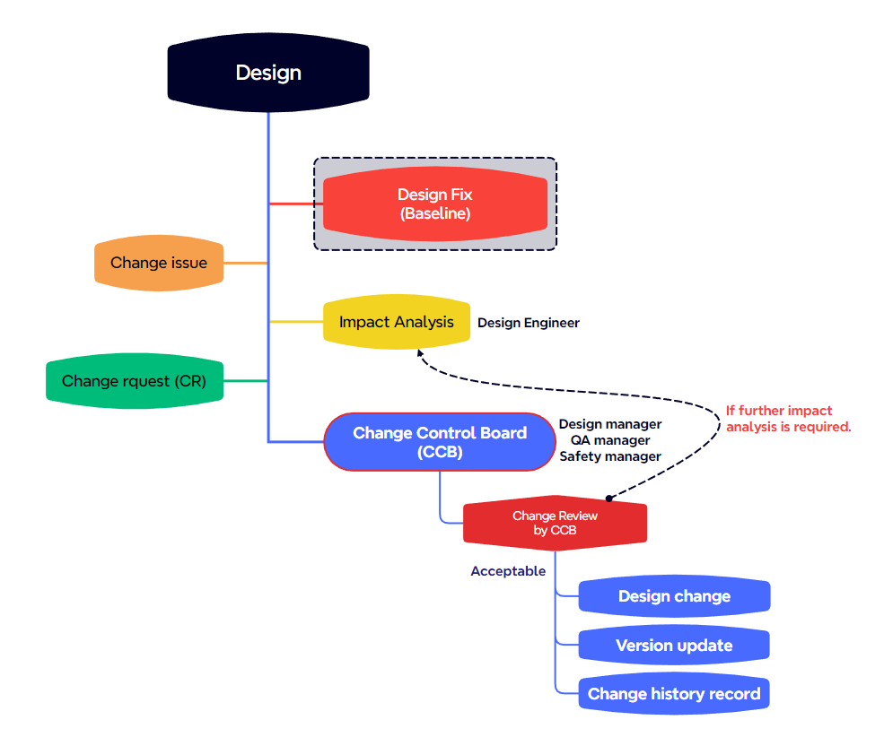
5. Process mapping


6. Work flow description
Phase #1 (Design Fix _ Baseline)
- This is the point at which the design is considered complete and formally approved as the baseline version for all downstream activities such as verification, layout, tape-out and testing.
- The finalized design (e.g., RTL, netlist, or layout) has passed all required reviews and sign off (e.g., functional verification, timing analysis, DFT integration)
- Once the design is fixed, any further change must go through a formal change control process.
- Design Fix is typically documented with version control tag, sign-off report, and baseline release note.

Phase #2 (Change Issue)
- If a problem is discovered after the design has been fixed – such as a bug, missed functionality or a customer request – it is documented as a change issue.
- The issue serves as a formal record and entry point in the change management process.
- Each change issue includes a description, severity, reproduction steps, and references to affected modules or documents.

Phase #3 (Impact Analysis)
- All relevant teams (design, verification, layout, QA, test engineering, etc.) analyze the potential impact of the change issue.
- This includes technical impact, re-verification scope, schedule impact, risk to product quality, and customer impact.
- The findings are complied into an impact analysis report which serves as the basis for decision-making.

Phase #4 (Change Request _ CR)
- Based on the results of the impact analysis, a formal change request is created.
- The CR outlines the reason for the change, a summary of the proposed modifications, affected files, or components, estimated schedule, resources needed, and risk assessment.
- The CR is submitted for approval via the change control process.
(

Phase #5 (Change Control Board _ CCB)
- The change control board (CCB) reviews the submitted change request and supporting analysis.
- The board consists of stakeholders from Analog solution, Digital solution, QA, Physical solution’s managers who have a responsibility of the changes.
- The CCB may approve, reject or request modifications to the change request. All decisions are documented and traceable.

Phase #6 (Change Review)
- Based on the submitted change request, the CCB review the risk and impact of the proposed change.
- The review evaluates whether the proposed change affects product performance, customer usage conditions, or introduces any potential risks.
- If the review concludes that the issued change is valid and appropriate, the CCB proceeds with approval based on consensus.
- If additional review or validation is required for the proposed change, the CCB requests further analysis from the responsible department. Once the additional review is completed, the CCB is reconvened to re-evaluate the validity of the change.

Phase #7 (Design Change)
- If the proposed changing is approved by the CCB, the required modification will be applied to the design.

Phase #8 (Version Update)
- After applying the modification to the design, DB version should be updated for history tracking.

Phase #9 (Change History Record)
- For history tracking about changing, the updated issue should be record on the change history sheet. (refer to the appendix #2)

7. Relevant document
Material | Form code | Description
Document management process | RS-SP-01 | -. Document management process.

Appendix #1
Design Fix Declaration |  |  |  | RS-SP-05-AP#1
Project name |  |  | Design/IP name
Project manager
Date of Fix Declaration
- Purpose
This document declares that the design has been fixed at a specific point in time and will serve as the baseline for further development. This ensures traceability and control over any subsequent changes.
- Scope
This declaration applies to the following design scope
- Design scope: (e.g., RTL / Netlist / GDS / Constraints)
- Design Fix Details
Items | Description
Fixed Design version | e.g., RTL v1.0 / GDS v0.92
Date of Fix | YYYY-MM-DD
Related Document | e.g., RTL Code, Schematic, Timing report
Simulation Results | e.g., pass / fail summary
Verification Status | e.g., functional / timing coverage %
DRC/LVS Status | e.g., summary of DRC and LVS results

- Change Control After
- Any changes after this design fix declaration must be reviewed and approved by the change control board
- All approved changes must be documented in the “change history log”
- Approvals
Role | Name | Signature | Date
Design Owner (AS)
Design Owner (DS)
Design Owner (PS)
Verification Owner
Project Manger
QA Representative

Appendix #2
Change Request (CR) |  |  | RS-SP-05-AP#2
Design/IP name | e.g., rs-dcphy3300_ln08lpu | Request ID | e.g., rs-dcphy3300_20250501
Requested by |  | Date of Request
- Change summary
- Title of change:
- Type of change
☐ : Function Change
☐ : Timing / Performance improvement
☐ : Bug Fix
☐ : Design rule / Constraint update
☐ : Customer issue / request
☐ : Functional safety
☐ : Others
- Change Description
- Reason for change (why is this change necessary):
- Proposed Change (Describe what will be changed and how):
- Impact Analysis
Category | Description
Affected blocks | Example: PLL, Driver.
Design version affected | Example: "RTL v1.02 will be updated to v1.03".
Verification impact | Example: “New regression required”, “Testbench must be updated for timing check”.
Timing impact | Example: “CDC checks required due to new clock domain.”
Physical impact | Example: “Floorplan adjustment needed due to macro shift.”
Schedule impact | Example: “May cause 1-week delay due to re-verification.”
Risk level | ☐ : Low – Minor doc update or comment fix  ☐ : Medium – Logic changes with verification  ☐ : High – Functional or architectural changes, timing critical path, major rework

- Attachments
Please attach any supporting files (schematics, simulation results, etc.)
☐ : File 1:
☐ : File 2:
☐ : DB code name after changing:
- Approvals
CCB (Change control board) | Name | Signature | Date
Analog solution (AS)
Digital solution (DS)
Physical solution (PS)
Quality assurance (QA)

Appendix #3
Change history log |  |  | RS-SP-05-AP#3  Update date:
Request ID | IP Name | Change | Revised DB name | Changed Date

